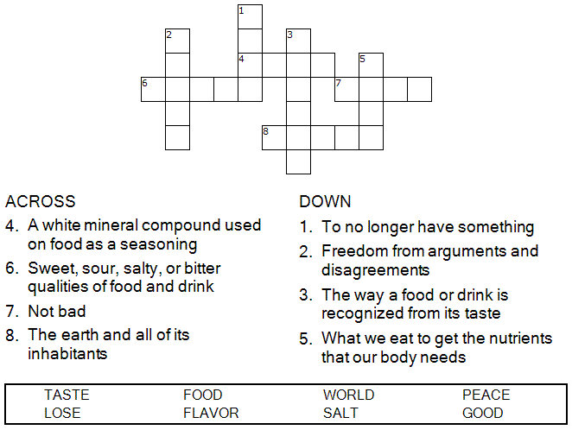



Copyright © Sermons4Kids, Inc.
May be reproduced for Ministry Use

Children’s Worship Bulletin

Pass the Salt, Please

Mark 9:38-50

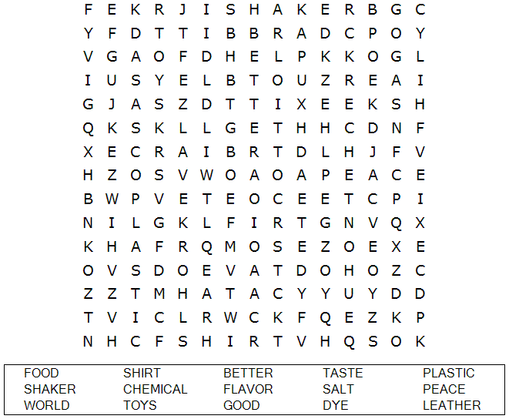

The Episcopal Church of St. Thomas the Apostle
6525 Inwood Rd., Dallas, TX 75209



“Salt is good, but if it loses its saltiness, how can you
make it salty again? Have salt among yourselves,
and be at peace with each other.”
Mark 9:50 (NIV)

Each number represents a letter of the alphabet. Substitute the correct letter for the numbers
to reveal the coded words.

